_______________________________________________________

Build Instructions: Wheelchair Wheels cleaner

To effectively clean the surface of wheels
Developed by:

Arunachalam Elanthendral, T., Blackwood, M., Bird, S., Damon, J., Ganotis, A., Henwood, J., Marks, A., Orford, E., Sor, N., Staaf, C., Thompson, A., Xerri, N.
And Mandy McCraken
_________________________________________________________________________

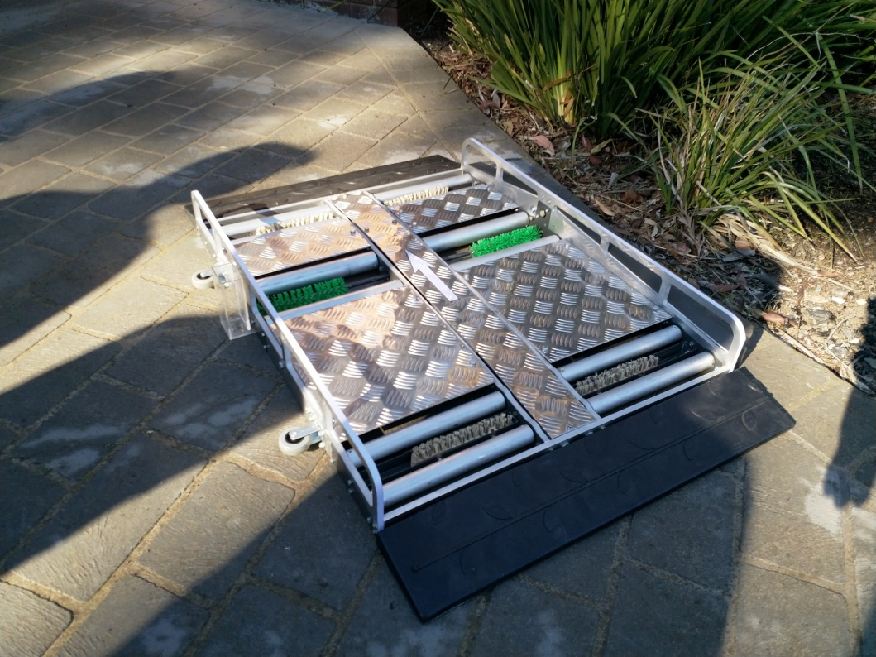

Approximate Material Cost: $1200 Time Required: 2 weeks

General Warnings and Cautions
- Read through entire manual before attempting to build this device.
- Do not attempt a step if you are unsure of what you are doing. Certain steps in this manual require experience with fabrication tools.
  - For assistance or clarification of any step, contact The Engineering Practice Academy.

User Assistance
For any questions regarding the assembly, operation or specifications of this device, please contact:
Engineering Practice Academy
Faculty of Science, Engineering & Technology
Swinburne University of Technology; Hawthorn (3122), Victoria, Australia.

Technical skill level
The product described in this Product File requires a high level of technical skill to modify and manufacture the product. Makers should be familiar with Solidworks Computer Aided Design software to make the necessary changes to the product files. Makers will also need access to specialist machining equipment to produce the components to the required accuracy and tolerances.

This product requires the majority of components to be modified digitally before being manufactured using a water jet cutter, or a laser cutter. These are specialist precision pieces of machining equipment used to cut steel and aluminum. Makers will need to find a business in their area that can provide these services and contact them for quotes and preferred file type for the specific equipment to have these components manufactured for this build.

Icon Glossary
The following icons may be used throughout this manual—each with its own purpose.
- Caution: The caution icon is used to signify whenever someone attempting the procedure may injure themselves or damage their equipment.
- Note: The note icon is used to signify useful bits of information that complement the instructions.
- Reminder: The reminder icon is used to provide information for after the procedure is completed, such as tips for disassembly.
- Need-Knower Specific: This part or method of manufacture has been designed specifically for a local Need-Knower.

Purpose of Device:
The purpose of this device is to clean the tire surface of the wheelchair wheels to remove dirt and any other remnants. The user would use this device before entering their house to ensure that the wheelchair wheels don’t spread dirt and remnants inside the house. The device is autonomous, using the movement from the wheels on the device.

This wheelchair is a common and popular type of a popular line.

Wheelchair model: Pride Mobility Quantum 600 Power Wheelchair
The wheelchair has 6 wheels and the main motive of this device is to clean the 2 drive electric wheels. The front and hind wheels will be cleaned as well by the device at a supplementary level.

The device is designed to enable a motorised wheelchair to drive up onto the device and stop so that the centre drive wheels are located between the central drive rollers and the smaller non-drive wheels of the wheelchair are located between the front and back rollers of the device. The user slowly drives backwards on the rollers, the drive wheels of the chair cause the central rollers to rotate; these are connected with sprockets and chain to the front and back rollers that transfer drive to the non-drive wheels of the chair. In this way the device uses the wheelchairs own power drive to rotate all wheels against both static and rotating brushes to clean the wheels of the wheelchair.

Physical Description:
The device is made up of over 70 individual parts (figure 1). The most vital parts include the ratcheting, gear and roller system; which creates drive to all wheels and gives them the clean that they require.
The main unit (roller unit) has two gradients, which reduce the entrance height of the device so that the ramp can conform to Australian standards for ramp height to flight ratios without having an excessive and cumbersome ramp length. The ramps attach to the main unit and are made of rubber.
The device consists of three sections; Entrance ramp, the roller mechanism and the exit ramp
The roller mechanism contains additional parts including:

- Brushes
- Rods
- Ratchet
- Gears
- Sprockets

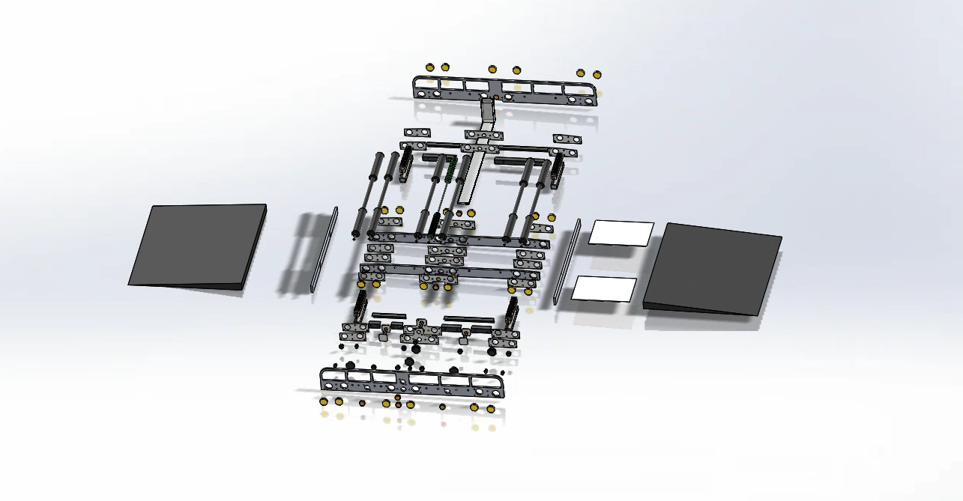
Figure 1: Exploded view of the device

History of Development:
This project began in 2018 as part of the first ‘TOM at University’ initiative in a joint-project between Swinburne Design Factory, Engineering Practice Academy at Swinburne University of Technology and Tikkun Olam Makers (TOM). This initiative had two stages, the first being the design development with design and occupational therapy students and the Need knower at the Swinburne Design Factory. The second stage involved Associates at the Engineering Practice Academy at Swinburne.
During the second stage at the Academy, the Associates, led by project facilitators Llew Mann and Alex Graham, worked on the feasibility and desirability aspects of the system. During this stage the unit was constructed and developed through co-design sessions with Mandy, the need-knower.

Bill of Materials:
This Bill of Materials relates to the device constructed for our Need Knower. Modification of the CAD files to suit individual wheel chairs will result in significant changes to the BoM. This table should be used as a guide to help plan the project, Makers should refer primarily to the CAD files for an accurate estimation of material required and cost of their own device.

Wheelchair Wheel Cleaner
Part ID | CAD Part name | Part Name | Notes | Description (mm) | Qty | Unit Cost  ($AUD) | Supplier | Total  ($AUD)
1 | Ramp | Ramp | Ramps may need to be cut to size | Ramp, 70x1000x700 (HxLxW) | 2.0 | 105.60 | Safety Xpress | 211.20
2 | Rotating Brush | Roller Brushes | Rotating Brush | Round Brushes,  185x45 (LxD) | 2.0 | 15.00 | Industrial Brushware | 30.00
3 | Assembly with Idler Bearings | 28mm Bearing | For drive rollers | Sealed bearing ,  28x12x8  (outer diameter x inner diameter x width) | 26.0 | 2.75 |  | 71.50
4 | Assembly with Idler Bearings | 10mm Bearings | For rotating brush and idlers | Sealed Bearing,  26 x 10 x 8 (outer diameter x inner diameter x width) | 10.0 | 2.00 |  | 20.0
5 | Full Assembly  ‘Sprocket 12 tooth’ | Sprocket and chain | See ‘Assembly with Idler Bearings’ | 20 tooth  12 tooth  Chain | 6 x 20 tooth  11 x 12 tooth | 194.00 |  | 194.00
6 | Full Assembly | Bolts |  |  |  | 50.00 |  | 50.00
7 | Full Assembly | Nuts |  |  |  | 25.66 |  | 25.66
8 | Full Assembly | Nylock nuts |  |  |  | 6.50 |  | 30.00
9 | Wheel | 50mm Caster wheels |  | 50mm Caster Wheel | 2.0 | 4.90 | Bunnings | 9.80
10 |  | Reflective tape |  |  | 1.0 |  | Bunnings | 10.00
11 | Static brush | Broom | Static brushes |  |  |  | Bunnings | 20.00
12 |  | Monument grey spray paint | Protect steel parts |  | 4.0 |  | Bunnings | 48.00
13 |  | Etch primer | Protect steel parts |  | 4.0 | 25.34 | Bunnings | 101.36
Part ID | CAD Part name | Part Name | Notes | Description (mm) | Qty | Unit Cost  ($AUD) | Supplier | Total  ($AUD)
14 | Checker Plate | Aluminium checker plate | Covers moving parts | 0.4 SqM | 1.0 | 28.00 | Breakwater Metal Land | 28.00
15 | ‘Side with Idler Bearings’  ‘Front and Back’  etc | Aluminium sheet Grade 5005 | Used for frame construction | 1200x600x10 (LxWxH) | 1.0 | 130.00 | Breakwater Metal Land | 130.00
16 | Roller Assembly 32mm | Alloy Tube  Grade 6033-T4 | Small rollers | 32x2400x3  (DxLxThickness) | 1.0 | 15.00 | Breakwater Metal Land | 15.00
17 | Roller Assembly 40mm | Alloy Tube  Grade 6033-T4 | Large rollers | 40x1200x3  (DxLxThickness) | 1.0 | 9.22 | Breakwater Metal Land | 9.22
18 | ‘15mm Spacer’  etc | Bright Steel shaft | Various spacers in the gear mechanism | 12x4500  (DxL) | 1.0 | 14.54 | Breakwater Metal Land | 14.54
19 | LHS & RHS total angle required | Checker plate mount | Refer to CAD for cut sizes | 25x25x3  (LxWxH) | 1.0 | 3.36 | Breakwater Metal Land | 3.36
20 | RHS & LHS  Backing Plate | Backing Plate  1mm Mild Steel sheet | Bearing backing plate | 0.36 SqM, 1mm thick | 1.0 | 5.10 | Breakwater Metal Land | 5.10
Part ID | CAD Part name | Part Name | Notes | Description (mm) | Qty | Unit Cost  ($AUD) | Supplier | Total  ($AUD)
21 | Static Brush Holder | Galvanised SHS Tube | Static brush tray | 30x30x800x1.6  (WxHxLxThickness) | 1.0 | 3.17 | Breakwater Metal Land | 3.17
22 | Gear cover | 1.6mm Mild steel sheet | Protects the sprocket and chain | 0.5SqM 1.6mm thick | 1.0 | 5.10 | Breakwater Metal Land | 5.10
23 | Support beams | Support beam,  Galvanised SHS | Support beams | 20x20x282x1.6  (WxHxLxThickness) | 4.0 | 15.30 | Bunnings | 15.30
24 | Water tray | Acrylic water tray |  | 750x60x130  (LxWxH)  Sheet size:  750x600x3  (LxWx Thickness) | 1.0 | ~60.00 |  | ~60.00
25 | Teflon Chain adjustment | Chain tensioners | Teflon cylinder cut to size for chain tensioners | Teflon cylinder | 1.0 | 50.00 |  | 50.00
26 | Collets | Collets | Stop the axles moving | 12mm Internal with grub screw | 12.0 | 2.00 |  | 24.00
27 | 12mm Axle | Bright Steel shaft | To make various axles/shafts | 12x4500  (DxL) | 1.0 | 14.54 | Breakwater Metal Land | 14.54
 |  |  |  |  |  |  | Approximate Material cost ($AUD) | 1198.85

Tools Required:

Protective gear
- Assorted PPE as appropriate (i.e. safety glasses, ear protection, dust mask, respirator)
- Welding PPE

Measuring / preparation
- Measuring device (tape measure)
- Set square
- Markers
- Clamps
- Utility knife

Tools
- Metal File
- Ratchet and socket set
- Assorted screwdrivers
- Electric Handheld Drill
- Standard High speed set of metric drill bits
- Mallet
- Tap Set

Specialist Equipment

- Welding equipment
- Laser cutter or Water jet cutter

Assembly:

We will tackle the assembly of the device in six different sections; structural frame, cleaning mechanism and rollers, internal mechanism, entry and exit ramps, waste removal and finish.
Safety features of the device are described in the internal mechanism section and in the finish section.

The instructions in this document are intended as a visual guide to be used alongside the CAD files for this device and provide visual examples of the major components described in each step so that Makers can identify the appropriate sections in the CAD files.
In regards to measurement specifications, this device was custom built for the Need Knower’s wheelchair. Hence, it is imperative that the measurement specifications of all the parts are adapted in the associated CAD files to suit the size of the wheelchair and given appropriate leeway and tolerances to ensure the safe operation of the device.
Makers should find and contact a local machine shop or engineering firm with access to a laser cutter or water jet cutter to manufacture the steel and aluminium components.

Pre assembly steps:
- Check measurements from CAD file.
- Compare with your wheelchair model to check if the measurements are appropriate.
- Adapt measurements as required to comfortably accommodate your chair.
- Test and draw all over the parts to create new parts with the appropriate specifications for your chair.

Step 1: Start Structural frame
- Measure your wheel chair wheel layout
- Compare the measurements to the CAD file measurements
    - Read the read me in the CAD files
    - Use the initialising document to help adjust the CAD files
- Note: Make sure the wheels are lined up straight and parallel with each other before taking measurements (fig 2)
- Measure all again (measure twice cut once)
- Modify the CAD files with your measurements
- Cut all sheet metal and aluminium for the frame (fig 3)
- Press fit bearings into the cut sheets (fig 4)

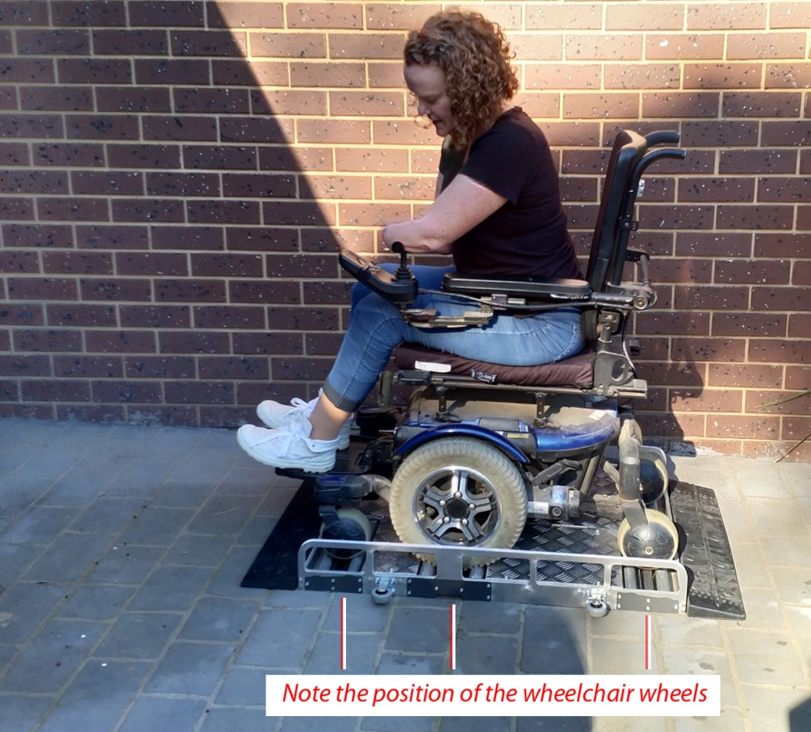
Figure 2: Mandy using the wheelchair cleaner, note the position of the wheels

Figure 3: The structure of the device highlighted in blue

Figure 4: Example of structural frame with bearings and backing plate

Step 2: Cleaning mechanism and rollers
- Cut the alloy tube, rollers, SHS and static brushes to length, use the updated dimensions from the CAD based on your wheelchair
- Construct the roller brush using alloy tube, bearings and collets (fig 5)
- Construct the rollers using the rube, bearings and spacers and hollow pipe sections (fig 6)
- Construct the static brush holder by modifying a SHS section using a saw or angle grinder to cut one side away (fig 7).
- Cut static brush and roller brush bristles to size – the bristles should lightly run against the wheels but not obstruct the rotation of the wheel
- The rollers can be assembled after the frame has been constructed by threading the shaft through the bearings, attaching each component as it passes the frame (fig 8)
- Collets and bearings will need to have grub screws and mounting screws tapped to mount them to the shaft, refer to the CAD files

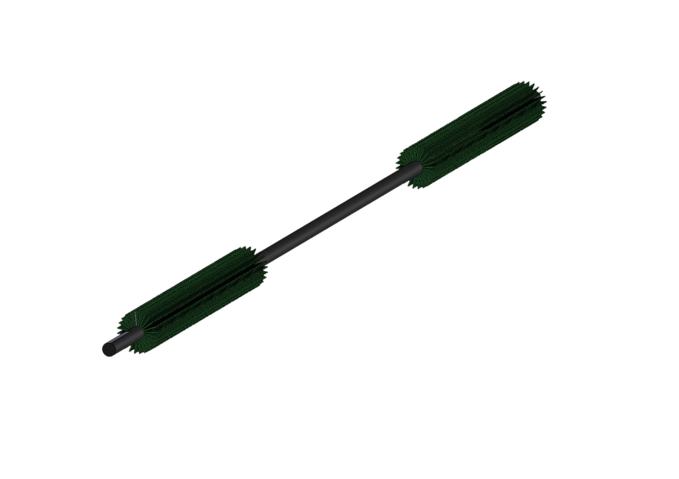
Figure 5: A single rotating brush should be constructed by threading the cylinder brushes along the shaft, mount these in place with spacers or screws

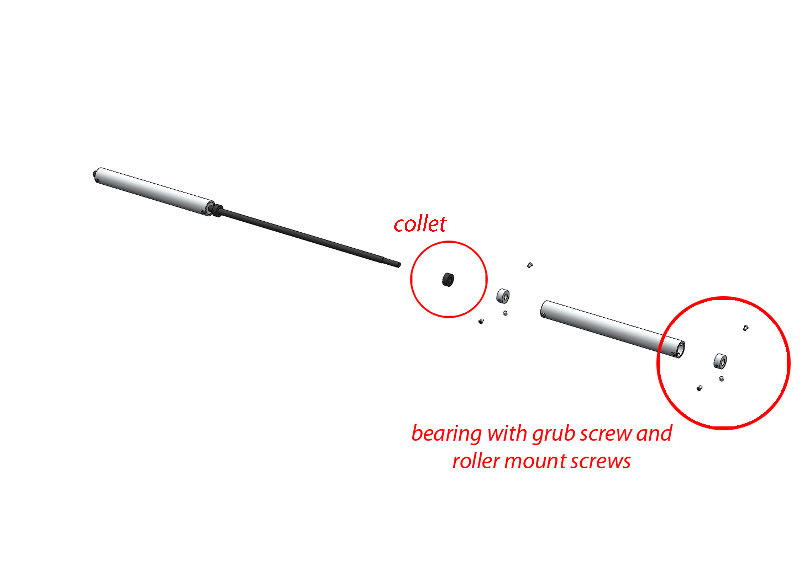
Figure 6: Detail of the roller construction, begin from one end and mount the different components to the shaft as you thread the shaft through the structure of the device

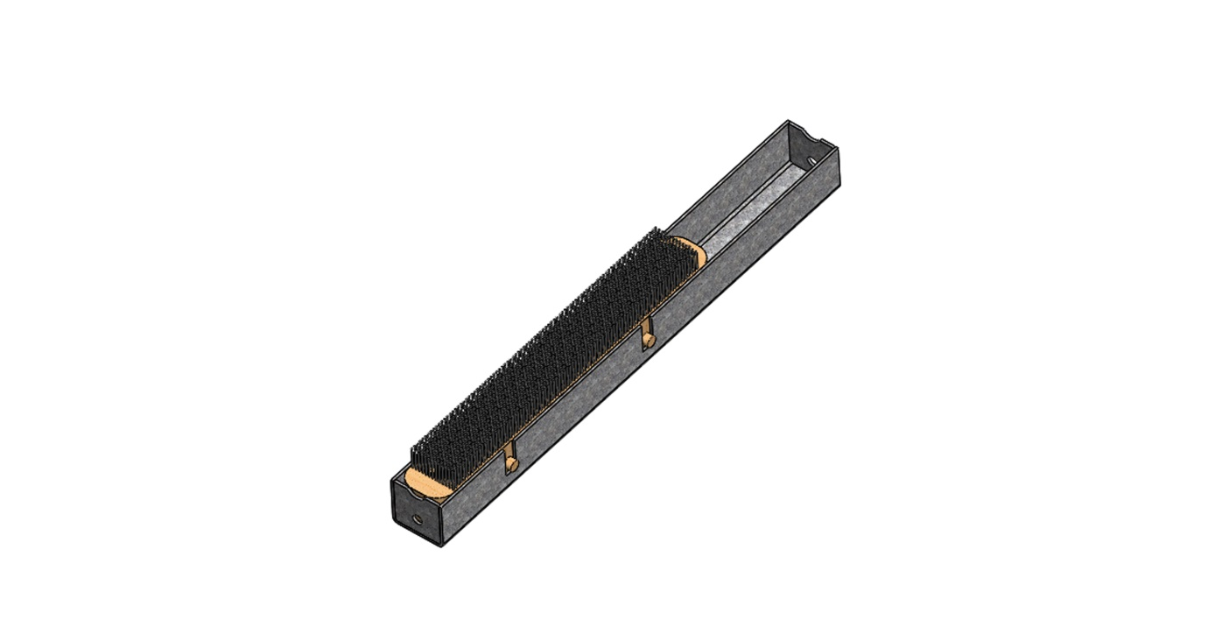
Figure 7: Example of a static brush

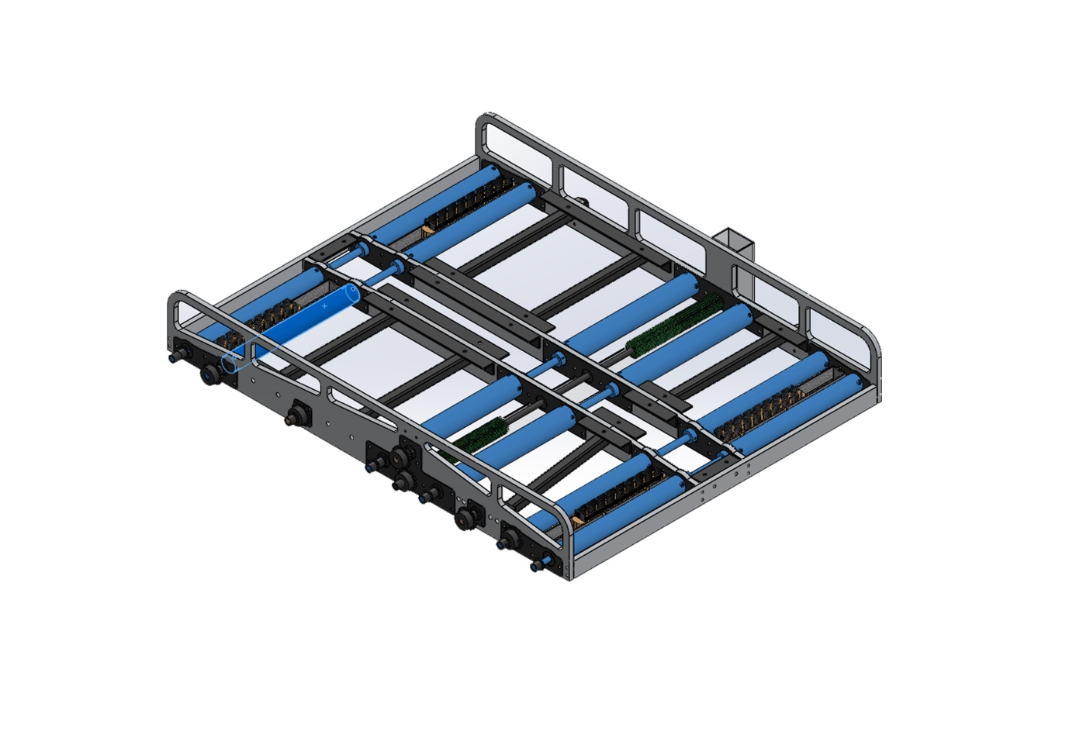
Figure 8: The rollers highlighted in blue, the centre rollers are constructed from larger diameter pipe and are driven by the drive wheels of the wheelchair

Step 3: Internal Mechanism
- With reference to the CAD model, add sprockets to the ends of the shafts
- Mount the chains to the sprockets, you may need to add or remove links in the chain to fit (fig 9, 10 & 11)
- Tension the chain using Teflon cylinder cut to size, you will need to position the Teflon tensioners in the desired position on the plate and drill holes to mount the Teflon using screws or bolts
- The position of the tensioners will change depending on the chain used, the modification of the design to suit the specifications of the individual wheel chair and the desired tension on the chain. This will require that the maker identify an appropriate position for the tensioners
- Add the ratchet mechanism with reference to figure 11 & figure 12, the ratchet will need to be placed according to the size and position of the individual sprocket set up. To mount the ratchet, drill a hole in the desired location to mount the metal tab and the spring. The spring keeps the ratchet in place. This part of the build will take some fine tuning and adjusting so be sure to place the ratchet correctly before drilling holes in the plates.
- When the user drives onto the device the rollers should be locked against this anti clockwise motion, the ratchet should release the rollers when the user puts the chair into reverse and the wheels are spinning clockwise.
- Test that the ratchet mechanism locks the rollers so that the wheelchair can be driven on and off the device safely by moving the rollers by hand
- Mount the cover plate over the mechanism to protect the components and safely cover the spinning components that could cause personal injury during operation

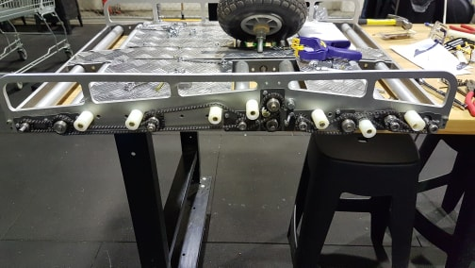
Figure 9: Arrangement of the chain and tensioners

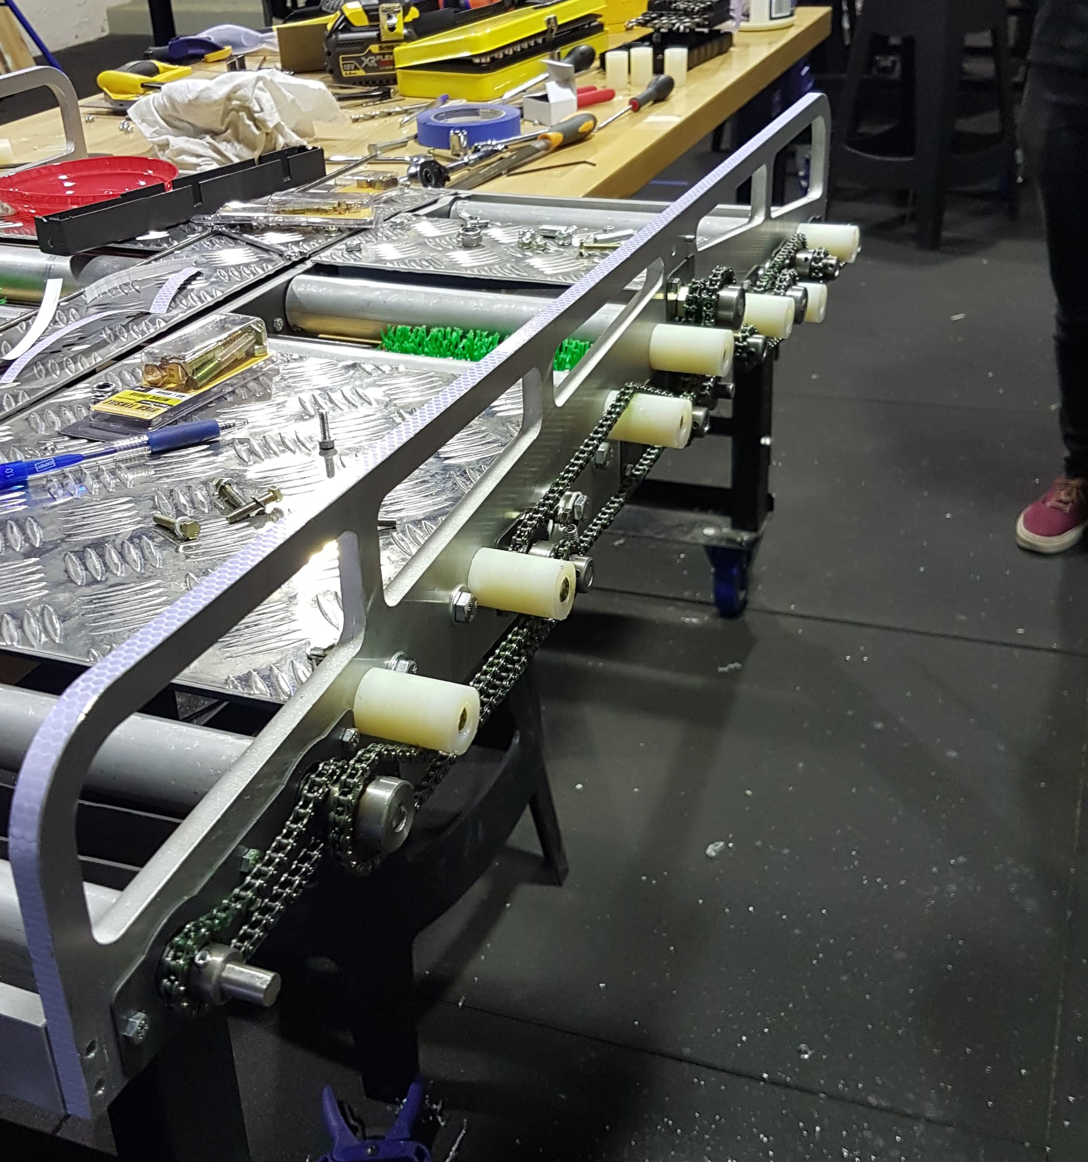
Figure 10: View of the Teflon tensioners and chain arrangement

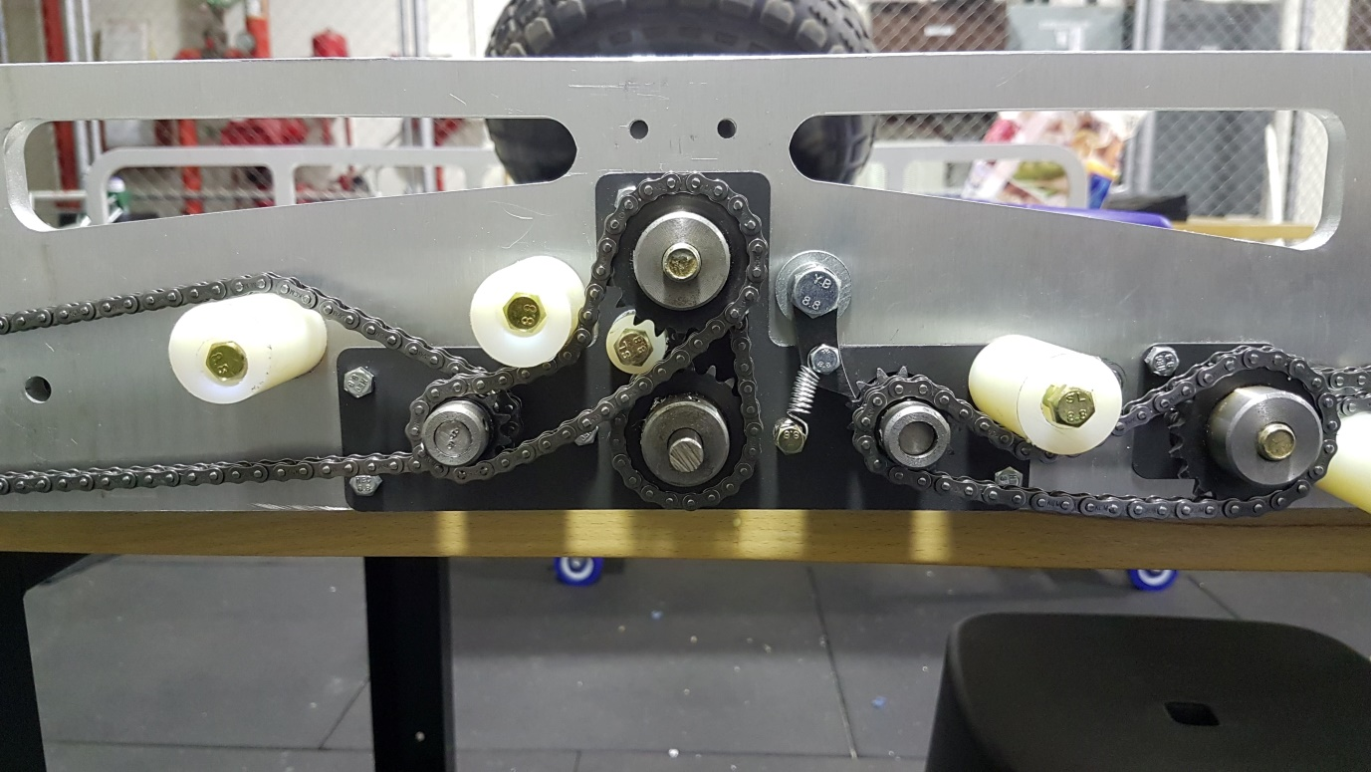
Figure 11: detail of the central mechanism driving the rotating roller

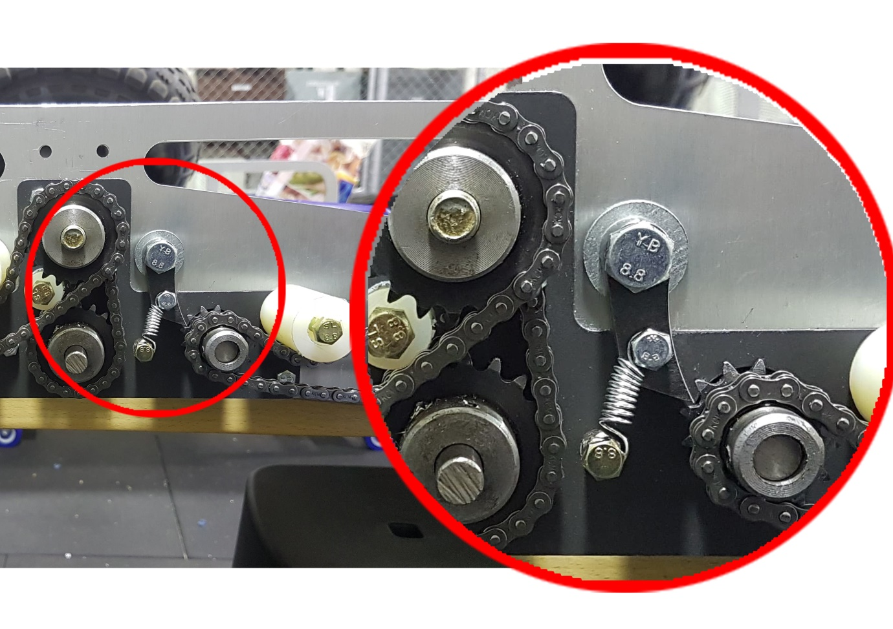
Figure 12: Detail of the ratchet mechanism

Step 4: Entry and exit system
- Find an appropriately sized ramp or cut the ramps from a large rubber wedge
- The height of the ramp should be level with the edge of the roller mechanism

- Note: Link ramp and structural system together, we found that the ramps remained in place without fasteners; however this may not always be the case

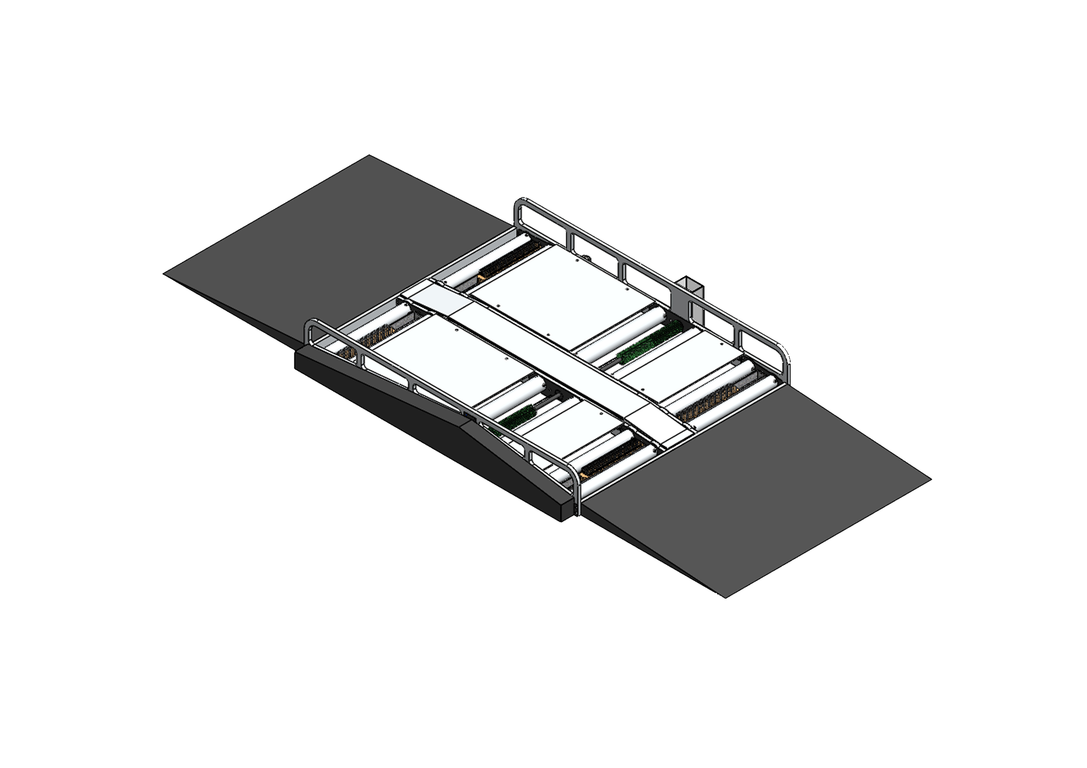
Figure 13: The complete device

Step 5: Waste removal system
- Take measurements from the updated CAD file
- Modify the waste removal tray based on your measurements, the tray should allow the rotating brush to dip into the water (fig 14).
- Cut acrylic to size – you can use a laser cutter or hand tools
- Assemble the tray using acrylic bonding glue
- Insert the tray into the predefined slot on the side of the roller mechanism (fig 15)

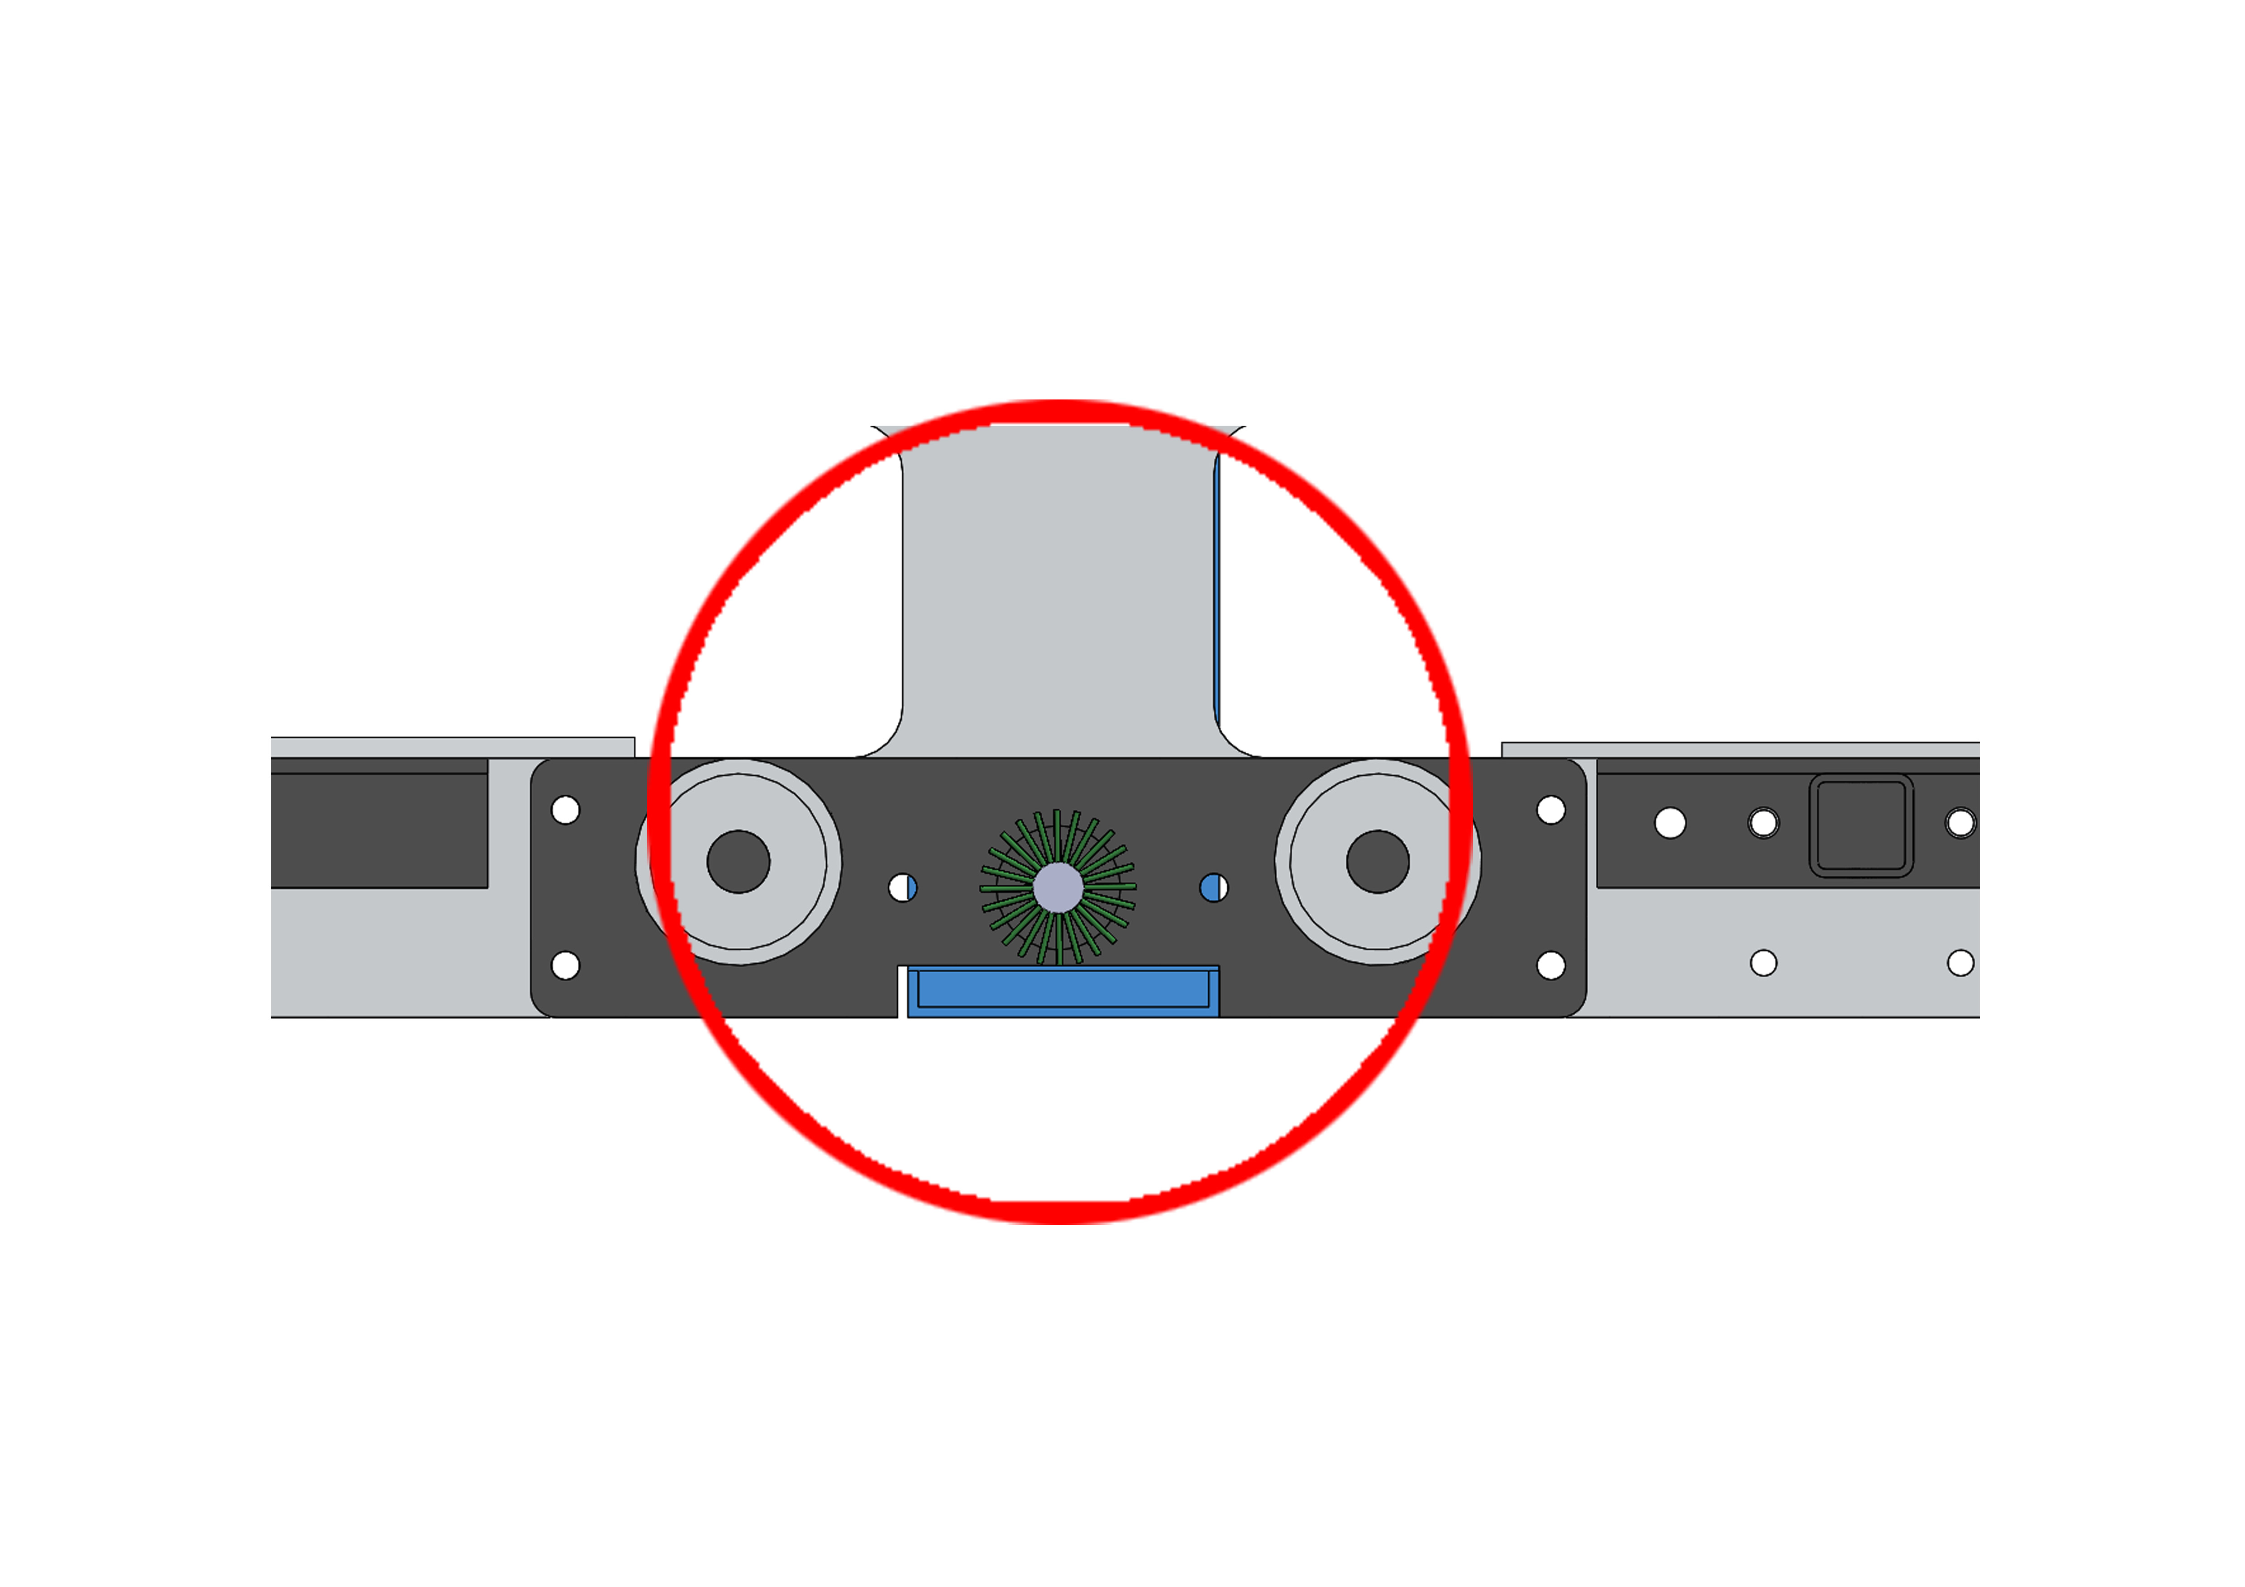
Figure 14: The water tray (blue) should sit at the level of the bristles (green) to lightly wet the rotating brush during operation

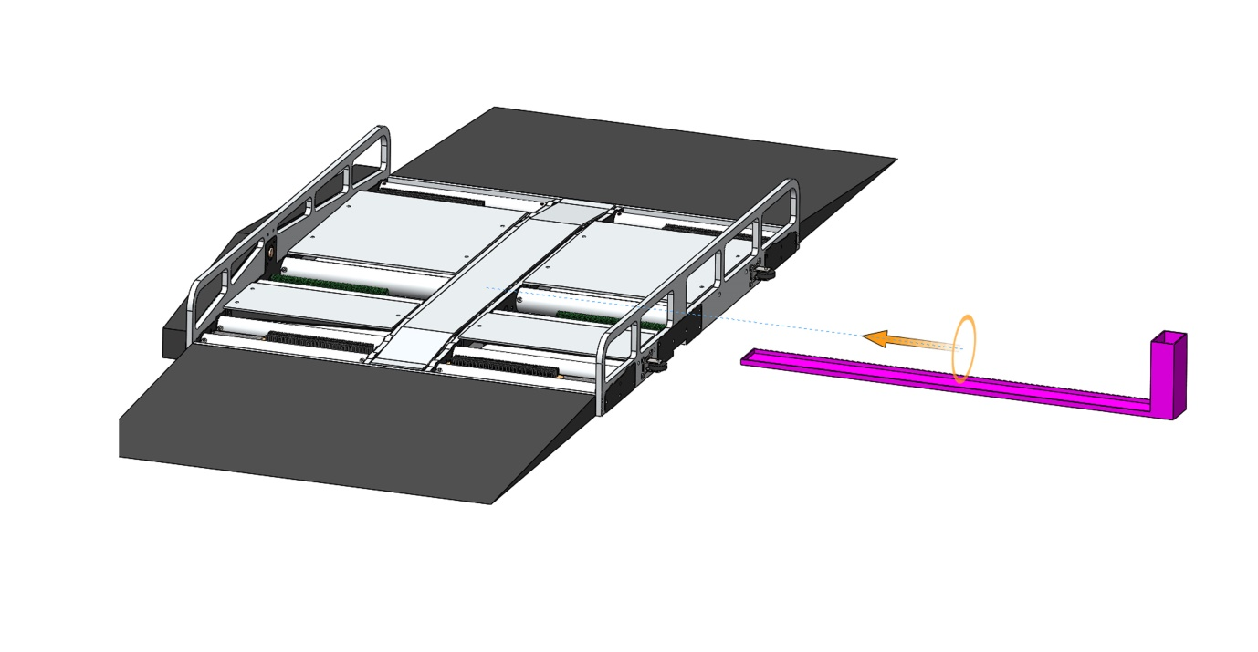
Figure 15: The water tray slides into a notch in the side wall

Step 6: Finish
- Attach caster wheels to the long side of the device that does not have the gear mechanism
- Conduct a visual inspection of any welds and other joins prior to mounting external plates and using the device
- Cover the internal components with steel or aluminium checker plates cut to size
- Add fluorescent markers as necessary along the middle of the device and side of the plates

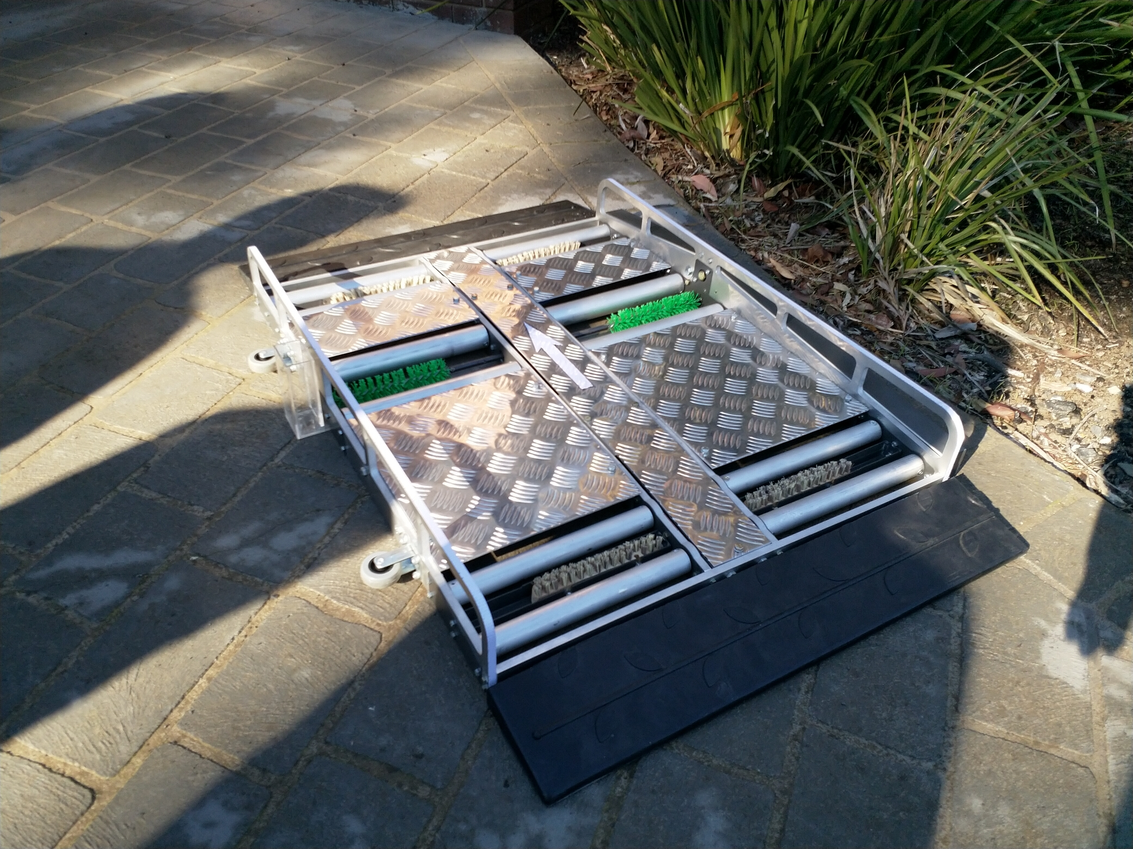
Figure 16: The completed device, note the reflective arrow in the centre of the plates to show the entry direction

