_____________________________________________

Build Instructions: Portable Ramps

Enable independent wheelchair users to mount kerbs and clear small height obstacles

Developed by: Stacey Christie, Alex Belinski, Lee Maaya, Zac Leigh, Rob Eales, David Jennings
________________________________________________________________________
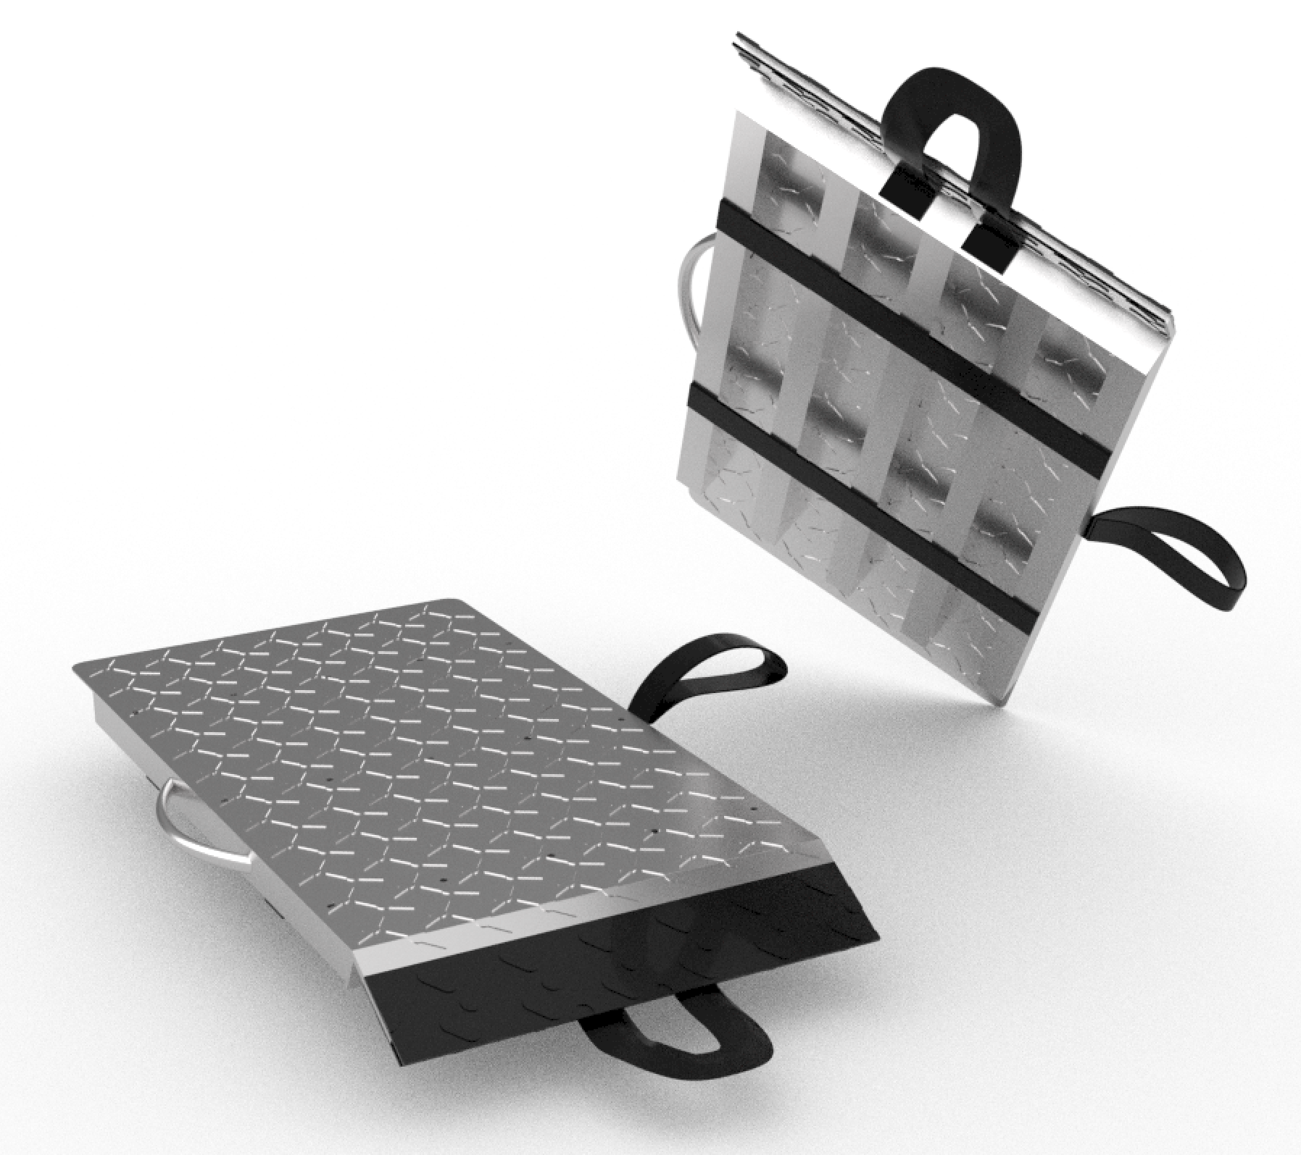

Approximate Cost: $250 Time Required: 4 hours

General Warnings and Cautions
- Read through entire manual before attempting to build this device.
- Do not attempt a step if you are unsure of what you are doing. Certain steps in this manual require experience with fabrication tools.
  - For assistance or clarification regarding the assembly, operation or specifications of this device, please contact ben@tommelbourne.com.au.

Icon Glossary
The following icons may be used throughout this manual—each with its own purpose.
- Caution: The caution icon is used to signify whenever someone attempting the procedure may injure themselves or damage their equipment.
- Note: The note icon is used to signify useful bits of information that complement the instructions.
- Reminder: The reminder icon is used to provide information for after the procedure is completed, such as tips for disassembly.
- Need-Knower Specific: This part or method of manufacture has been designed specifically for a local Need-Knower.

Purpose of Device:
Portable Ramps are designed to allow wheelchair users to independently move over kerbs, gutters and other small height obstacles while moving through a town or city. The device is meant to be used for a single step or kerb.

Physical Description:

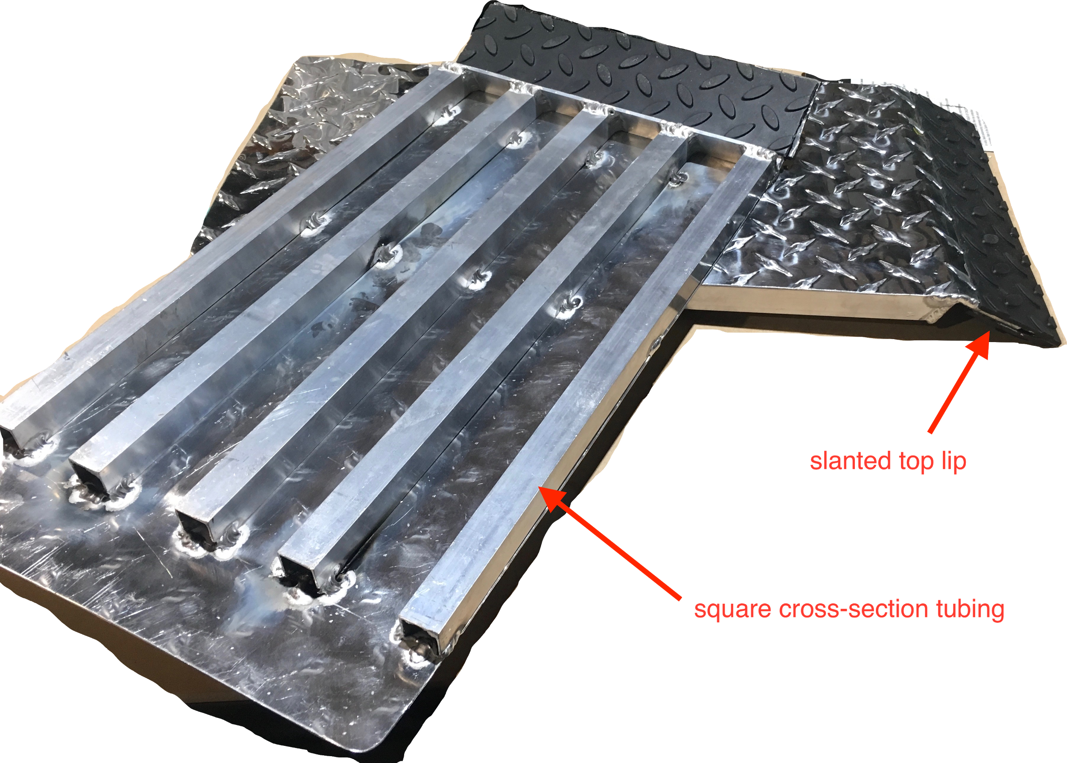
- Two (2) aluminium flat ramps, each with
  - Slanted top lip: for stabilisation on the gutter, kerb, step, etc
  - Square cross-sectional aluminium tubing: for structural reinforcement
- Telescopic pole: for deployment of ramps
- Rubber grip tape: to prevent the ramp from slipping
- Side handles: for picking up and placing the ramp*
*Note: The side handles have not been included in the above image.

History of Development:
This is the second iteration of this project. The first iteration (2016) called Step Up produced a portable ramp outcome that is detailed in Appendix 1: Existing Documentation, Step Up, Stacey’s Challenge: Negotiating Steps and Curbs.

Bill of Materials

Part ID | Part Name | Description | Qty | Dimensions | Supplier | Unit Cost | Cost
A | Ramp top plate | 1.2 mm Aluminium Propeller Plate | 2 | 600mm (H) x 300mm (W) | Bunnings | $28.47 | $56.94
B | Support tubes | Metal Mate  19 x 19 x 1.2mm Aluminium Square Box Tube | 4 | 1m (L) | Bunnings | $8.90 | $35.60
C | Lip | Metal Mate Aluminium Unequal Angle 50mm x 25mm x 3.0mm | 1 | 1m (L) | Bunnings | $23.49 | $23.49
D | Rubber | Croc Grip 420mm x 120mm Checker Plate Rubber Step | 2 | N/A | Bunnings | $12.98 | $25.96
E | Pole | Fizan Compact Hiking Pole | 1 | N/A | Kathmandu | $83.98 | $83.98
F | Side Handles | Grunt 25mm x 10m Poly Webbing Black | 1 | N/A | Bunnings | $6.50 | $6.50
 |  |  |  |  |  | TOTAL COST | $232.47

Tools Required:
- Power drill
- Hacksaw or other metal saw
- Welder*
- Angle grinder suitable for cutting aluminium
*Note: If welding equipment is inaccessible, aluminium parts can be joined using screws. We created a functional prototype using 10g x 18mm Sheet Metal Self-Tapping Pan Head Slotted Phillips Drive Screws from Bunnings to secure the ramp top sheet to the support tubes.

Parts Inventory (Assembly) :

Part No. | Part Name | Description | Qty | Units
A | Ramp top plate | Flat aluminium checker plate cut into two sections of 500mm (L) x 250mm (W) | 2
B | Support tubes | 19.05mm square cross-sectional tube cut into 10 sections of 400mm length | 10
C | Lip | Aluminium unequal angle cut to 250mm length | 2
D | Rubber | Checker plate rubber strip cut into 250mm (L) x 60mm (W) strips | 4
E | Pole | Telescopic hiking pole | 1
F | Handles | Polyester webbing side handles | 4
G | Straps | Polyester webbing back straps | 4

Exploded Assembly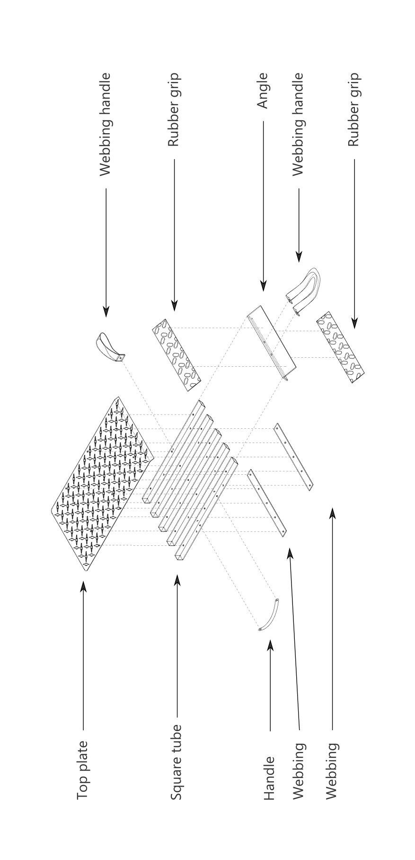

Assembly

Step 1: Cut the aluminium plates to size
- Measure out 500mm x 250mm portion of both plates (Part A)
- Use angle grinder to cut the plates to these dimensions
- Round off corners
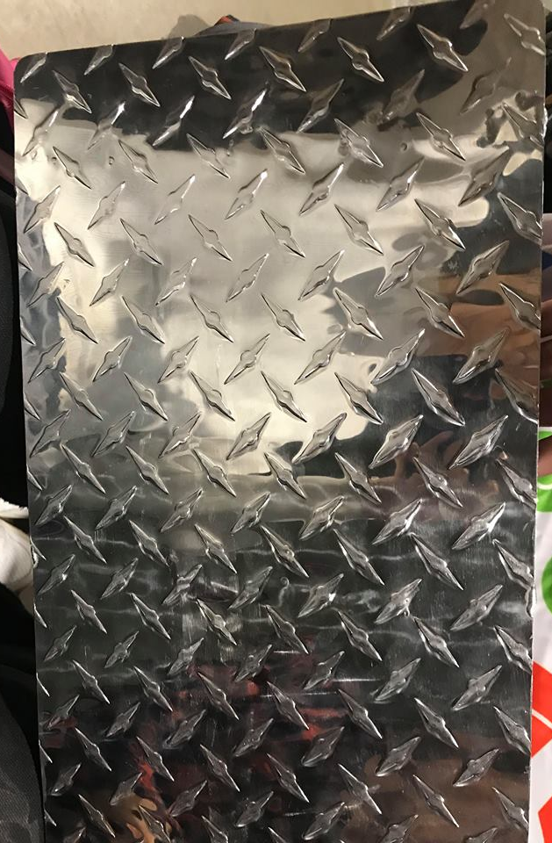

Step 2: Cut support tubes into shape
- Measure 10 sections of 400mm length along the square cross-sectional aluminium tubing (Part B)
- Use a hacksaw to cut into (10) 400mm portions of the tube
- Cut one end of the tube so the edge is approximately at a 30 degree angle per picture below

Step 3: Connect tubes to angle L-section to make the ramp frame
- Cut aluminium angle (Part C) to 250mm length
- Place the 5 tube pieces equidistant apart along the outside edge of the small lip of the L-section
- Weld tubes to angle lip along each edge of the square section of the tube
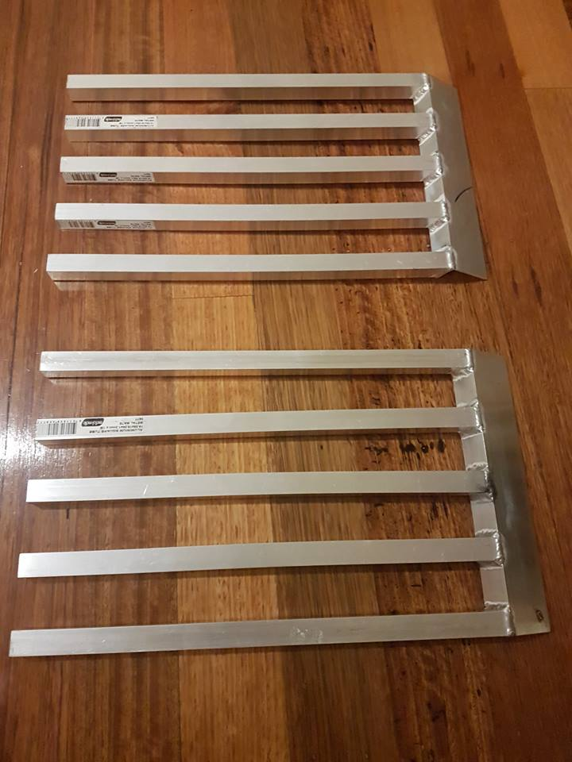

Step 4: Connect plate with the ramp frame
- Measure plate on-top of frame leaving a distance of 45mm from the bottom end of the frame and 20mm on the top end.
- Spot weld top plate (Part A) to square tubes (Part B)
- Bend the 20mm top plate section over the L-section (Part C)
- Weld top plate to L-section

Step 5: Add rubber lining to the L section lip
- Cut rubber checker plates into 250mm (L) x 60mm (W) strips
- Pull off paper adhesive backing from one strip and stick to the top of the lip (Part C), aligning lengthwise with the edge of the aluminium top plate (Part A)
- Pull off paper adhesive backing from second strip and stick to bottom side of lip, aligning edges with the first rubber strip (see image below)
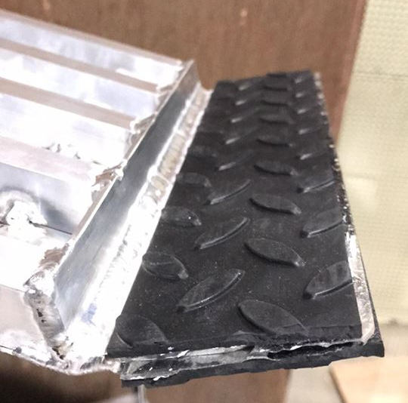

Step 5: Add side handles and back straps
- Cut polyester webbing into four lengths of 100mm and four lengths of 250mm
- Attach 100m sections to the top and side of each ramp in a handle formation. The top handle should be fastened to the underside of the lip using rivets or screws.
- Attach 250mm sections across the backside of the ramp. These straps should be secured flat to the square tubing with rivets or screws. The first strap should be placed approximately ⅓ down the length of the ramp, and the second strap should be placed approximately ⅔ down the length of the ramp.

Congratulations, you have built two lightweight portable aluminium wheelchair ramps!

CAD Files
The 3D CAD files for this project can be found here, https://drive.google.com/open?id=1dQCDg62SuK5eWuwqUZIudIKgZBgEV5op

Future Work
Unfortunately, given the limitations of Stacey’s wheelchair, our ramp design did not meet our intended specifications regarding the desired step height they could mount. We were hoping to reach a step height of 200mm, but in our testing Stacey was only able to comfortably mount steps of approximately 150mm maximum.
To rectify this problem, we determined that the ramps would need to be at least 750mm long (instead of 400mm), and have thus begun to draft an alternate design involving a fold-out portion that extends the ramp length. This version will not be as lightweight and portable as the current design.
In future iterations, we plan to install a mechanism that will make it simple for Stacey to place the ramps the correct distance apart from one another. Ideas for this mechanism include a folding lever to act as a spacer, or color coding the ramps for faster alignment. See images below for examples.
